Project Design Phase-II
Data Flow Diagram & User Stories

Date | 31 January 2026
Team ID | LTVIP2026TMIDS82987
Project Name | Strategic Product Placement Analysis: Unveiling Sales Impact with Tableau Visualization
Maximum Marks | 4 Marks

Data Flow Diagrams:
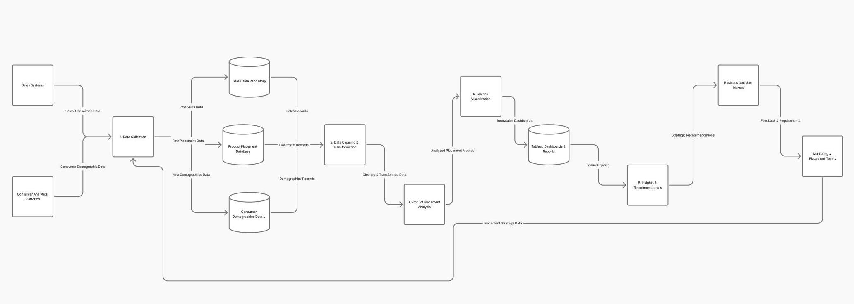

User Stories
Use the below template to list all the user stories for the product.
User Type | Functional Requirement (Epic) | User Story Number | User Story / Task | Acceptance Criteria | Priority | Sprint
Visitor | Navigation Interface | US-01 | As a user, I want to view a navigation bar to access all sections easily | Navbar displays Home, About, Dashboard, Story, Team, Video, Contact links | High | Sprint 1
Visitor | Home Page Display | US-02 | As a user, I want to see project title and tagline on landing page | Title, tagline, video, and links visible on homepage | High | Sprint 1
Visitor | External Links Integration | US-03 | As a user, I want clickable GitHub, Tableau, and YouTube links | Clicking links opens respective resources in new tab | Medium | Sprint 1
Visitor | About Section | US-04 | As a user, I want to understand project overview and problem statement | About section displays overview, problem, and solution clearly | High | Sprint 1
Visitor | Tableau Dashboard | US-05 | As a user, I want to view interactive Tableau dashboard insights | Dashboard loads fully without cropping and allows interaction | High | Sprint 1
Visitor | Tableau Story | US-06 | As a user, I want to explore story-based visual insights | Tableau story loads and slides can be navigated | Medium | Sprint 1
Visitor | Team Section | US-07 | As a user, I want to see team member details | Team members shown in 2×2 grid with name, college, branch | Medium | Sprint 1
Visitor | Video Section | US-08 | As a user, I want to watch project explanation video | Embedded YouTube video plays within website | Low | Sprint 1
Visitor | Contact Form | US-09 | As a user, I want to submit queries using contact form | Form accepts name, email, message and validates inputs | High | Sprint 2
Admin (Project Owner) | Email Notification | US-10 | As an admin, I want to receive email notifications from contact form | Email received with user details after form submission | High | Sprint 2
Visitor | Smooth Scrolling | US-11 | As a user, I want smooth scrolling between sections | Clicking navbar scrolls smoothly to selected section | Medium | Sprint 1
Admin | Backend Processing | US-12 | As an admin, I want Flask backend to process form submissions | Form data processed and email sent without errors | High | Sprint 2

